

**EXELLENT COACHING CENTER**

**4-nov-2025**

**Prepared by**

**Syeda Ghousia**

**STUDENT ID:** **1657437**

**EMAIL: syedanoornoman123@gmail.com**



1



**Table of Contents**

1. **INTRODUCTION**
2. **OBJECTIVES**
3. **PROBLEM STATEMENTS**
4. **HARDWARE / SOFTWARE REQUIREMENTS**

2

INTRODUCTION:

Excellent Coaching Center is a modern educational platform designed to provide quality learning and reliable guidance to students. The purpose of this website is to create an effective link between teachers and students, making class schedules, course information, and important study material easily accessible. Through this system, students can get all academic updates from home with ease. The website is user-friendly, fast, and designed for simple navigation so every student can benefit without difficulty. This platform is built to enhance learning standards and support students throughout their academic journey.

3

3

OBJECTIVES OF THE PROJECT

* To provide students with easy access to class schedules, course details, and study materials anytime and anywhere.
* To build an effective communication system between teachers, students, and administration.
* To digitalize coaching center records such as admissions, notices, results, and announcements.
* To create a user-friendly and responsive website that works smoothly on all devices.
* To save time and improve the learning process through fast and organized information sharing.
* To promote an efficient and modern online learning environment for student growth and success.

4

So what is this e-Project?

E-Project is a step-by-step learning environment that closely simulates the classroom and Lab based learning environment into actual implementation. It is a project implementation at your fingertips!! An electronic, live juncture on the machine that allows you to

o Practice step by step i.e. laddered approach.

o Build a larger more robust application.

o Usage of certain utilities in applications designed by user.

o Single program to unified code leading to a complete application.

o Learn implementation of concepts in a phased manner.

o Enhance skills and add value.

o Work on real life projects.

o Give a real-life scenario and help to create more complicated and useful applications.

o Mentoring through email support.

The students at the center are expected to complete this e-Project and send complete project along with the documentation to e-Projects Team

Looking forward to a positive response from your end!!

5

5

6

Requirement Specification:

The Web site is to be created based on the following requirements.

1) The Home Page should have suitable logo, and decent color combination.

2) Information should be neatly placed at suitable location.

3) Various pages having information about different courses/subjects taught at the classes, Faculty/Teachers complete information and previous year’s success stories should be listed.

4) The site should display a menu which will contain options for brief introduction about the above-mentioned information, location/address of the coaching classes and any other information if required.

5) The information should be categorized according to different subjects like if a User wants to see details of ‘Commerce’ then he clicks on a Link/button/menu etc. and he will see details of course structure of commerce. Similarly, for ‘Mathematic’, ‘Languages’ and other subjects.

6) When a user selects any course stream, complete list of subjects for that course stream will be displayed.

7) Details of the courses should be displayed on the Web Page along with the title and it should be stored in Individual Word documents which can be downloaded or viewed by the User who wishes to see the same.

8) Price List for all courses should be available for download.

9) There should be a “Contact Us” page which will have the Address of the Coaching Classes and the mail address which when clicked will invoke the local mail client from where they can send an email.

6

PROBLEM STATEMENTS

Excellent Coaching Center currently uses traditional methods to share academic information such as class schedules, course details, and study materials. Due to manual communication, students often face difficulties in getting timely updates regarding classes, assignments, and announcements. There is no centralized system where students and teachers can interact efficiently. To solve these issues, a dedicated website is required that provides instant access to academic information and improves communication between students, teachers, and administration.

SOFTWARE REQUIREMENTS

* **Visual Studio Code**
* **Google Chrome / Edge**
* **Bootstrap 5**
* **HTML, CSS, JavaScript**

HARDWARE REQUIREMENTS

**Processor:** **Intel i5 or above**

**RAM:** **8GB**

**Hard Disk:** 500GB

7

screenshorts

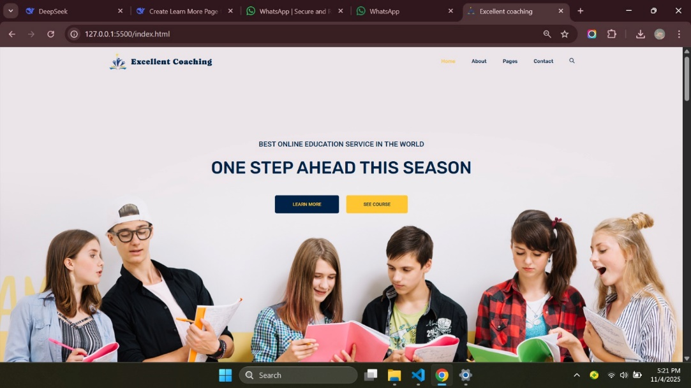

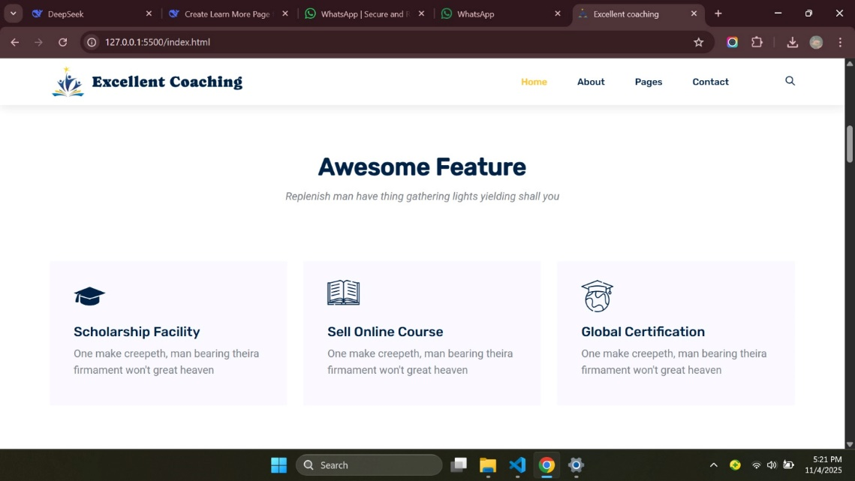

8

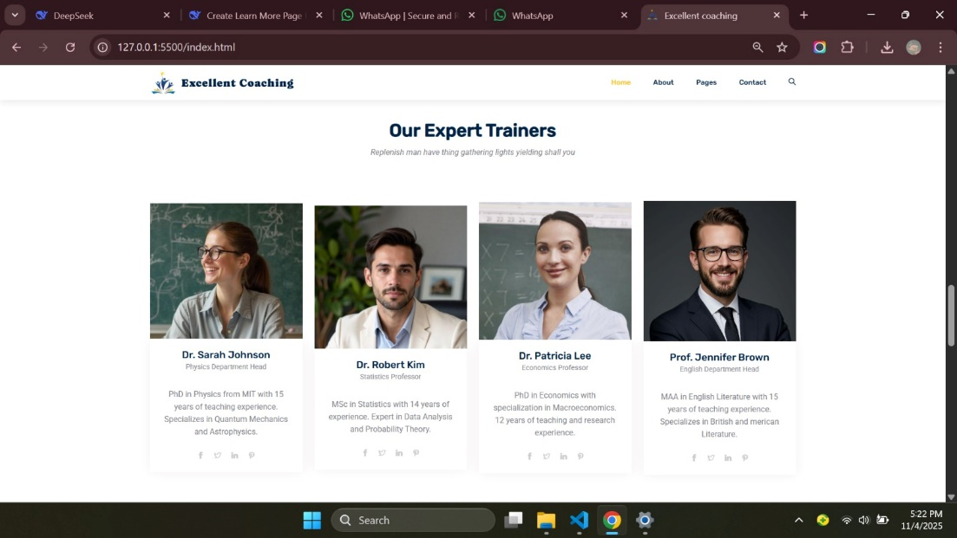

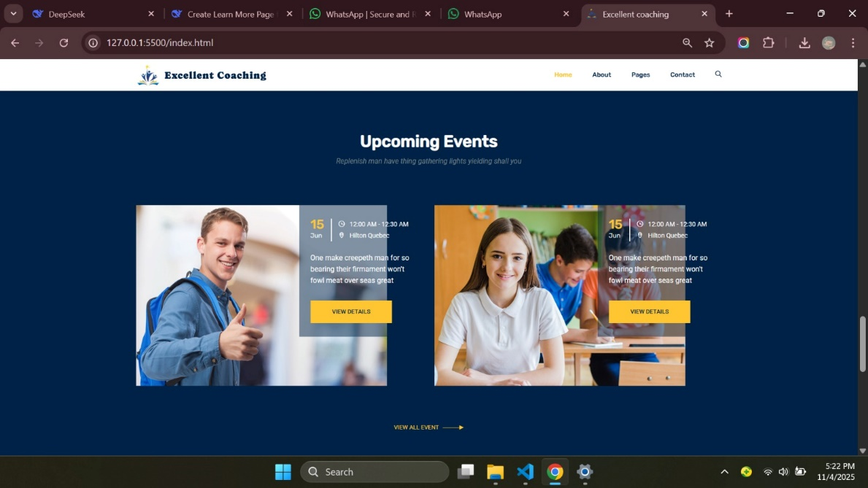

9

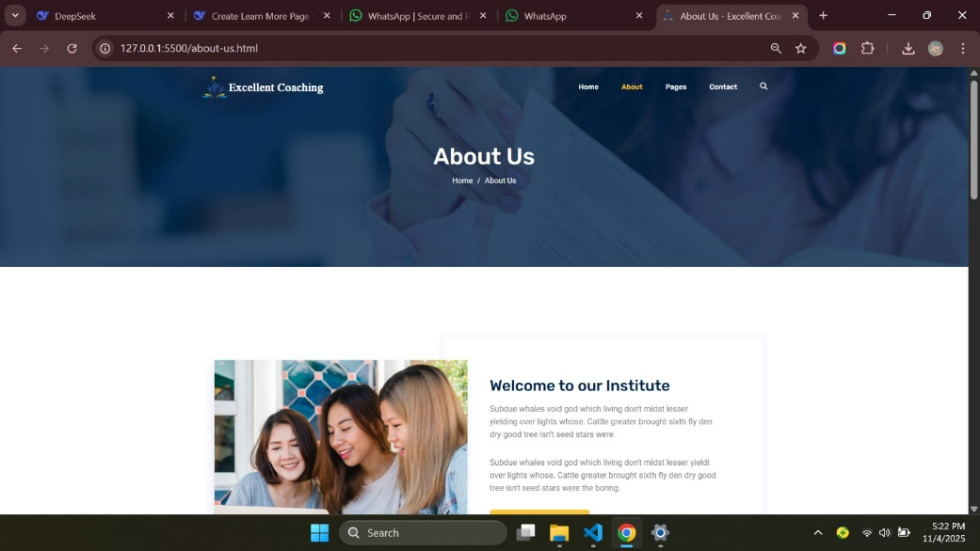

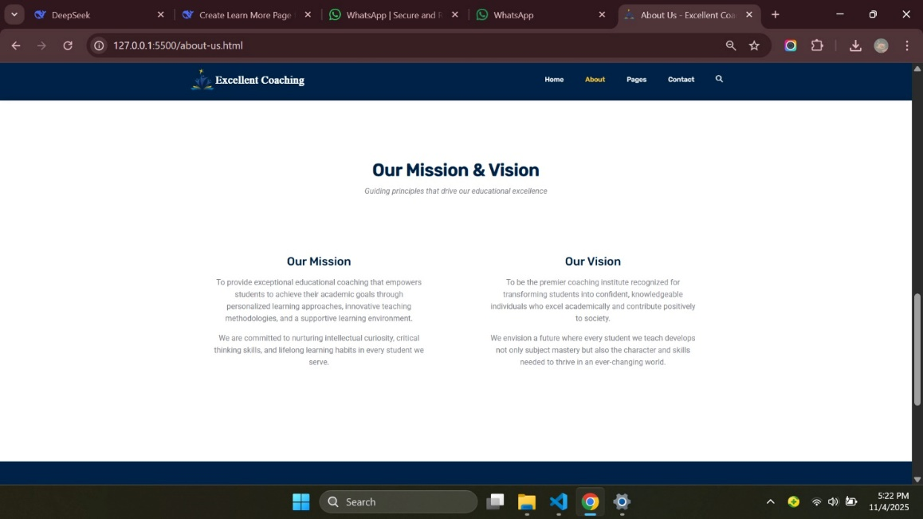

10

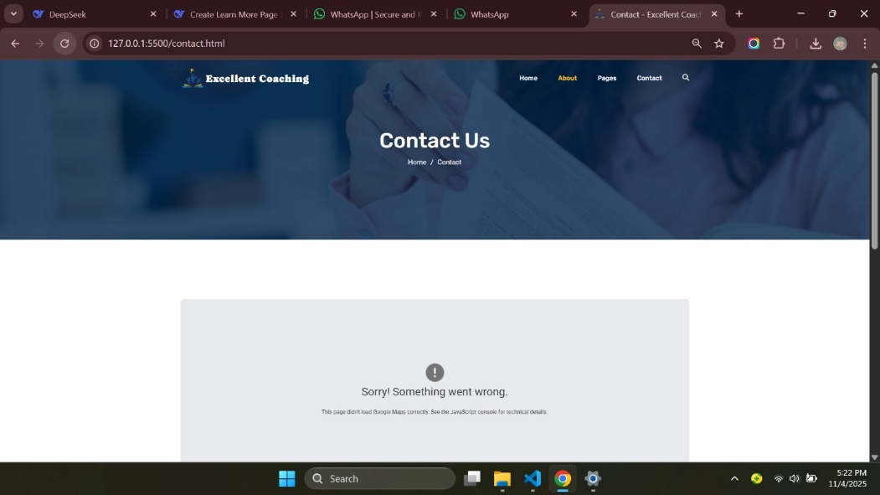

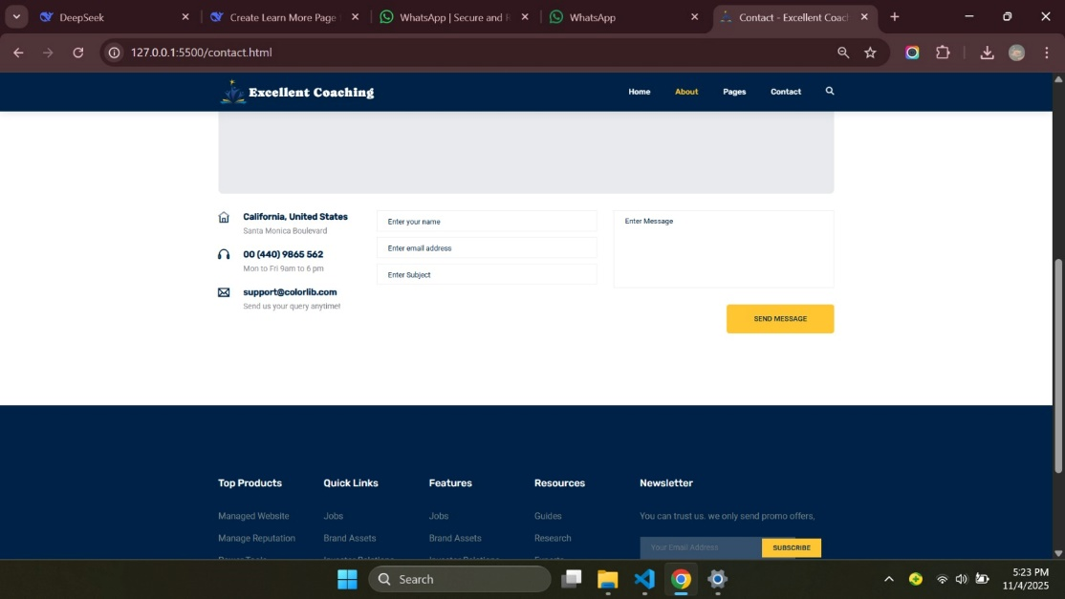

11

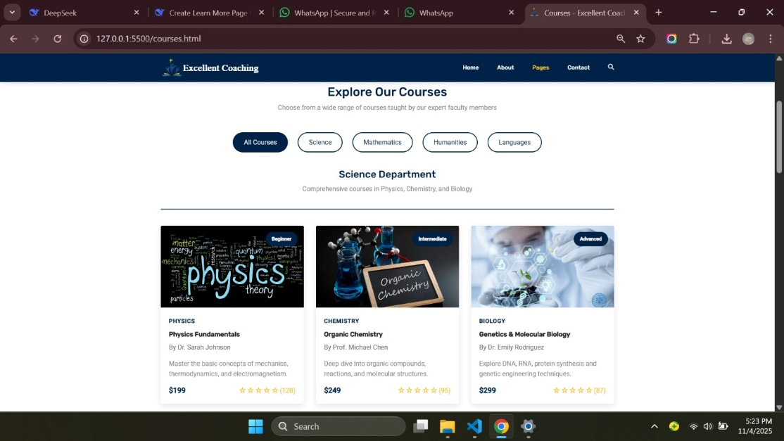

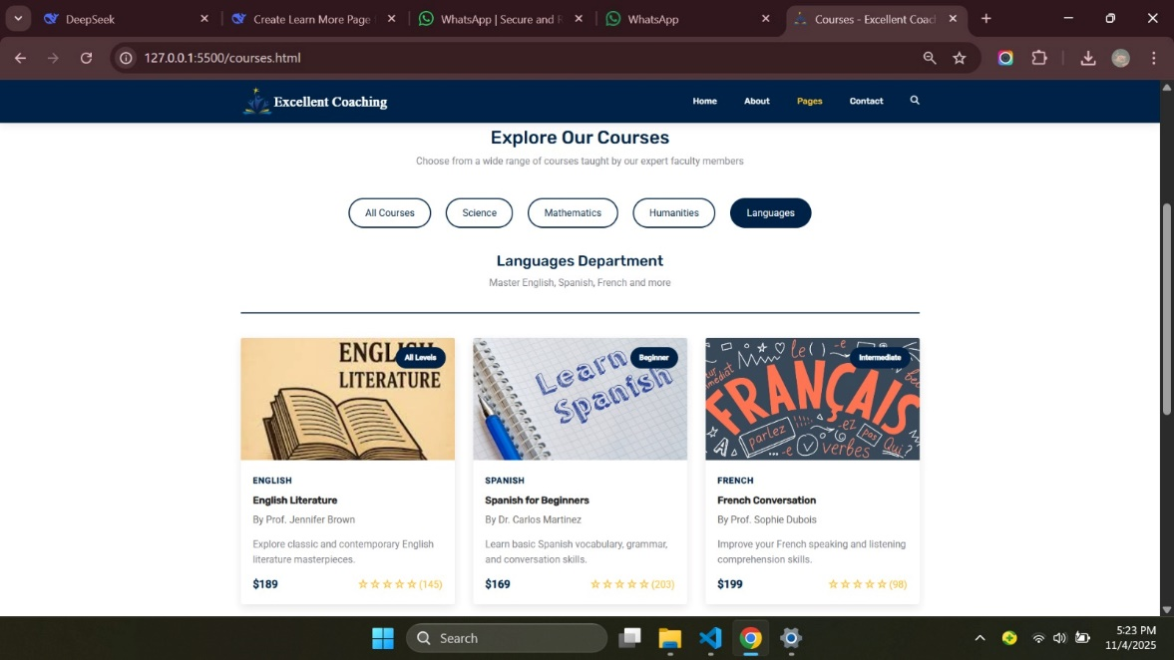

12

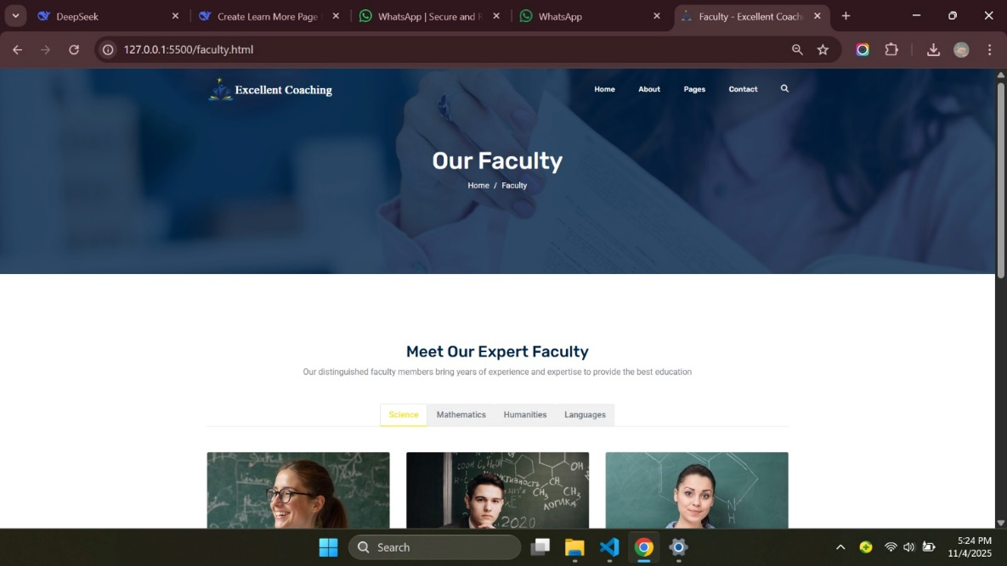

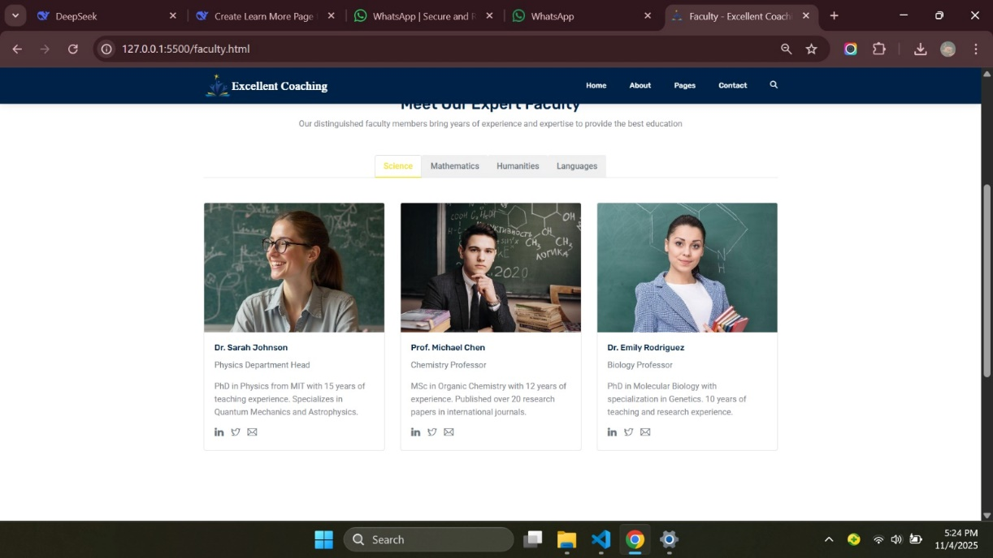

13

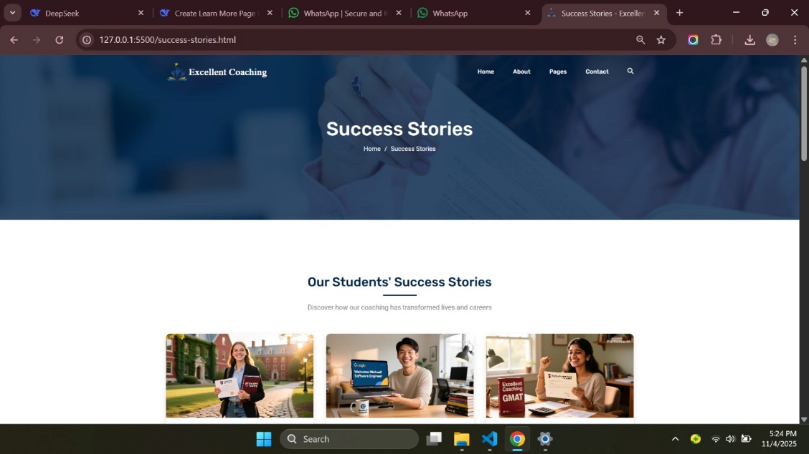

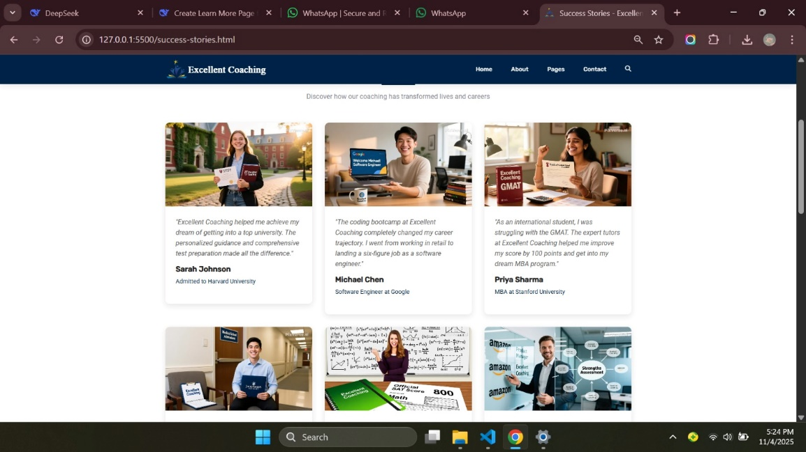

13

THANK YOU!

14

14